**ELK Setup**

1. Download elastiSearch. Unpack and start elasticsearch.bat (apple: elastisearch) via command line. In Browser open <http://localhost:9200/> to check if it works properly (needs some time).
2. Download kibana. Unpack and start kibana.bat (apple: probably kibana) via command line. In a browser open <http://localhost:5601/> to check if it works properly (also needs some time).
3. Download logstash. Unpack the zip file. Open a command line and navegate logstash\bin, now enter: logstash -e 'input { stdin { } } output { stdout {} }' (Maybe “ instead of ‘). If the output says “Successfully started Logstash API endpoint”, enter “hello world”, you should receive something like this:  
   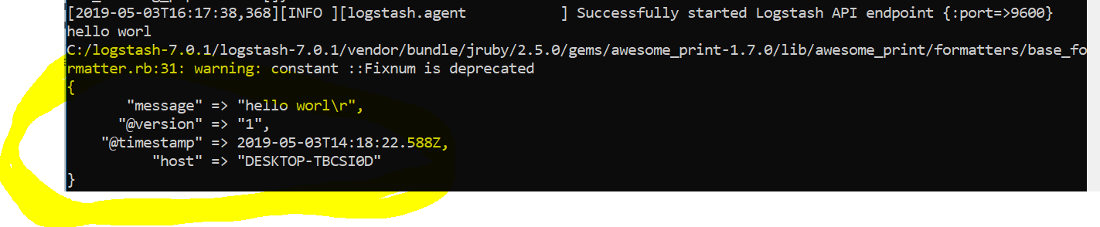

**Run ELK in Docker**

<https://www.codementor.io/samueljames/using-docker-with-elasticsearch-logstash-and-kibana-elk-dzucc3c94>

<https://logz.io/blog/elk-stack-on-docker/> (is unfortunately taking ages to run)

<https://elk-docker.readthedocs.io/> (documentation of the same image)